ACORN

A COnservation Records Network

User Manual

Weissman Preservation Center and Library Technology Services,

Harvard Library

Cambridge, MA



# TABLE OF CONTENTS

Page #

What is ACORN? 4

Intended Audience 4

User Types 4

Signing In 5

Changing Your Password 5

Signing Out 5

Menu Bars 6

Home Page 8

Common Conventions 8

RECORDS

New- Record 9

Login a Record 10

Transfer Form 11

Create/ Edit a Proposal 14

Email Proposal 15

Proposal Approval 16

Create/ Edit a Report 18

Files 19

Logout a Record 21

Temp Transfer and Temp Transfer Return 21

Create a New Project 21

Create/ Edit Custom Text 22

Group Records 24

Create a New Group Record 24

Group- Login and Logout 25

Group- Proposal and Report 25

Status 27

Bulk Login and Bulk Logout 28

OSW- On Site Work

OSW 30

SEARCHING AND REPORTS

Find A Record- Simple 32

Find a Record- Advanced 33

Reports (PDFs) 36

ADMIN FUNCTIONS

Initial Setup Instructions 37

Edit- Lists 37

Edit- Person or User 39

Delete a Record 41

Close a Record/ Mark As Done 41

Delete and Rename Files 42

Unlock a Record 42

Global Options- Custom Text and Saved Searches 42

REPOSITORY MODE

Signing In 43

Menu Bars 43

My Records 44

Identification 44

Proposal and Report 44

Find- Record 44

Edit 44

Repository Admin 45

Glossary 46

# WHAT IS ACORN?

ACORN (A COnservation Records Network) is a database for preservation documentation to be used by conservators of artistic and historic materials.

There are four major tasks that ACORN can perform. They are:

1- Registrarial/ tracking system for objects entering and leaving a conservation lab or other preservation space.

2- Depository for treatment documentation- written and visual, embedded and linked. Data can be shared and accessed by conservation, registrarial, and curatorial units.

3- Tracking system for preservation work and/or conservation activities. This may include activities such as environmental monitoring, emergency response, quick assessments, quick repair or other treatment related activities that do not have a full proposal.

4- Statistics queries- for example, amount of treatment hours by person, project, repository, or statistics by work type.

A built-in search engine makes information retrieval simple. As a web-based system, ACORN allows users to access the data at various locations and is a sustainable paperless system. All data is stored locally, either with the user or the user’s institution.

# INTENDED AUDIENCE

ACORN is intended for the conservation community and allied professionals. It is useful for keeping track of preservation activities for multiple repositories/clients.

# USER TYPES

* **Admin**- the Admin has access to all areas that a Regular user has with additional functions such as editing lists, deleting Records, opening Records, etc. An Admin can sign on as any category of user; useful for testing functions and troubleshooting.
* **Curator**- the Curator can approve, deny, and comment on proposals and reports. The Curator can only access ACORN through an email link.
* **Regular**- A regular user has full access to all records in ACORN, regardless of Repository. Functions include creating Records, writing and editing of Records, uploading of files and full searching.
* **Repository**- A Repository user has Read Only access to all records for their repository. A few fields have write access. Repository users can Login and access Records directly.
* **Repository Admin**- A Repository Admin has all the rights of a Repository user with additional functions such as the ability to create Pending Records and a complete list of active Repository records on My Records screen.

# SIGNING IN

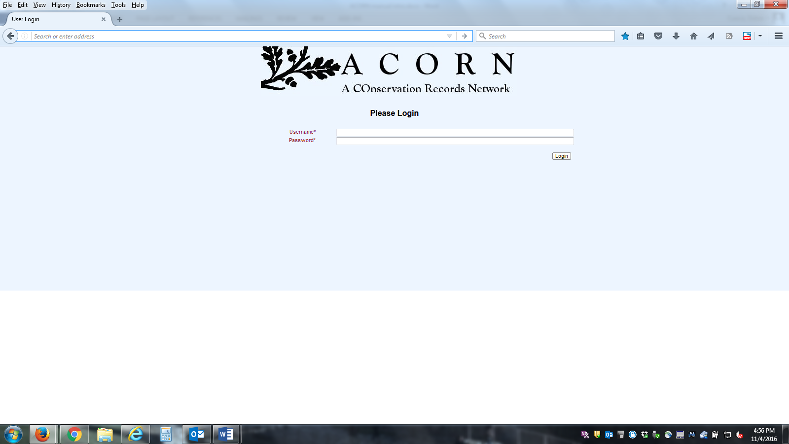

Open Mozilla Firefox or Google Chrome. Enter in the local pathway to the ACORN database. Make sure your browser is up to date.

Once an Administrator has entered the user into the database the user can log in with the assigned username. The username and password are initially the same. Only keep one browser window open at a time.

# CHANGING YOUR PASSWORD

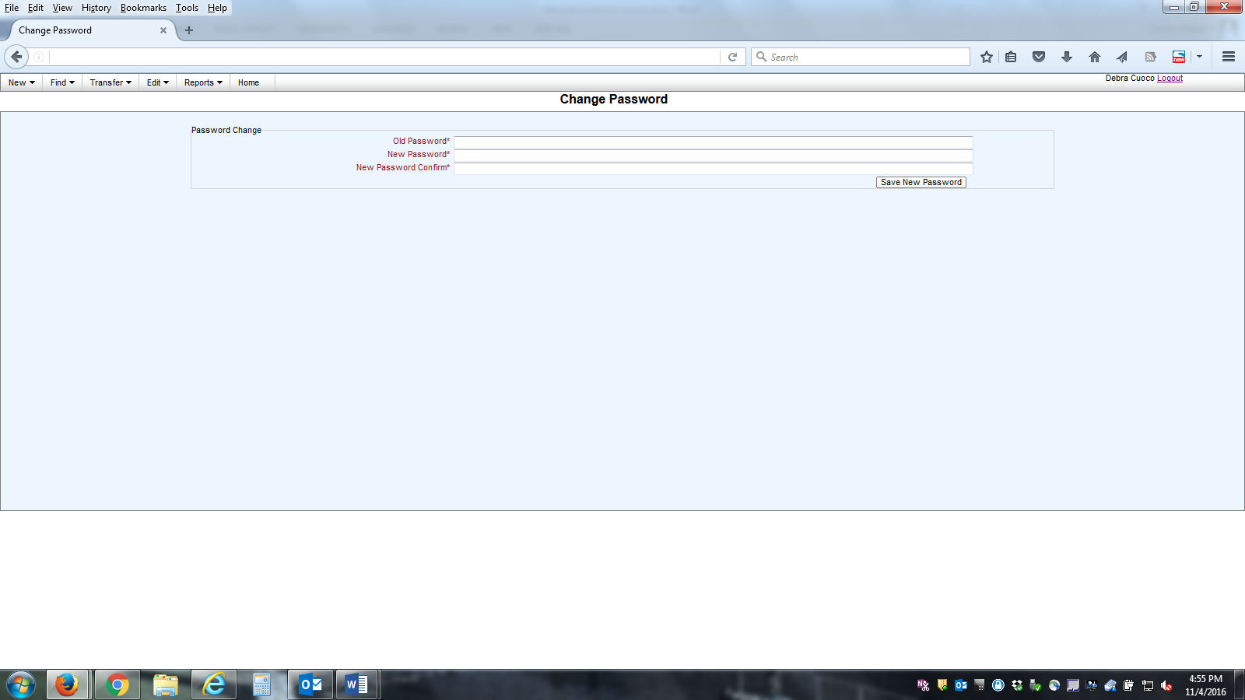

On the upper Menu bar click Edit—Password to change the password.

An Administrator can reset the password.

# SIGNING OUT

Return to the Home screen and click Logout on the top right corner.

# MENU BARS

NEW-

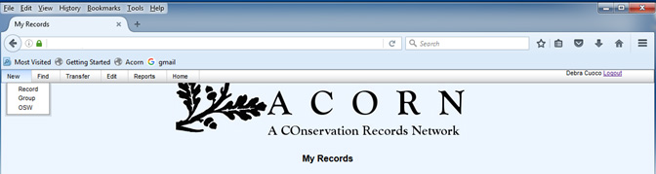

FIND-

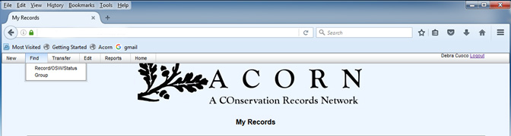

TRANSFER-

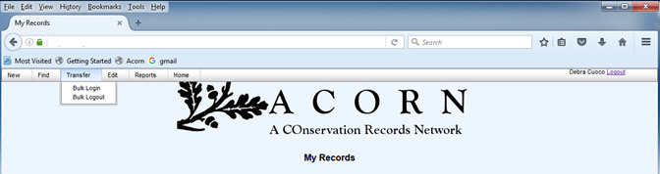

EDIT-

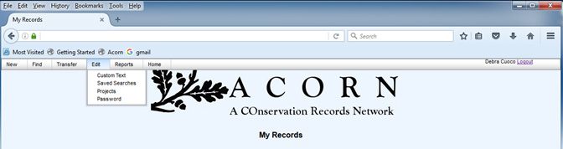

REPORTS-

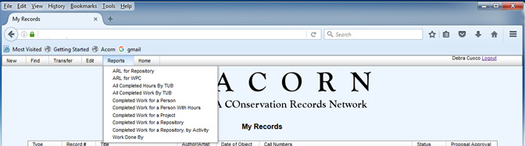

# HOME PAGE

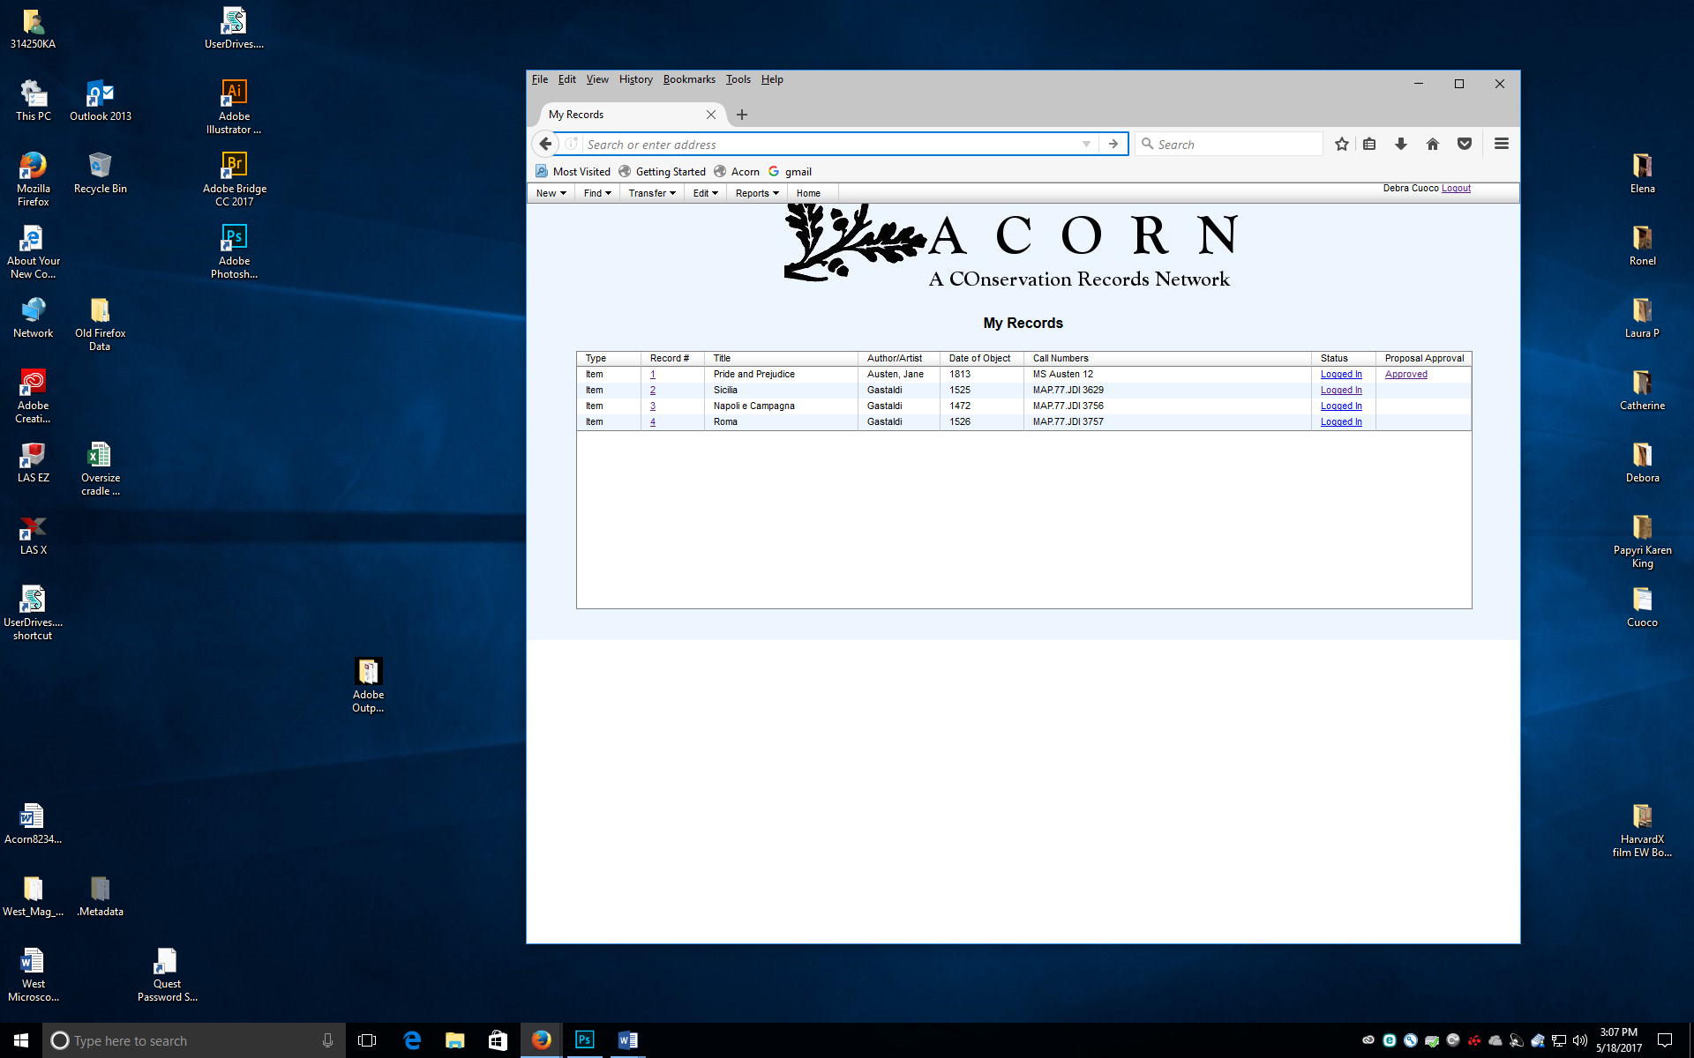

The Home page lists all work that is currently in progress for a user. Basic identifying information for the records (Regular and OSW) are presented. Hyperlinks are available in three locations.

* **Record** #- brings user directly to a **Record** or **OSW**
* **Status**- brings user to Status page
* **Proposal Approval**- brings user to **Proposal Approval** subpages of the Proposal tab.

Once a Record has been Logged Out (Regular Records) or Closed (OSW), it will no longer remain on the My Records page. The Search function must be used to retrieve a Closed or Logged Out Record.

# COMMON CONVENTIONS

* Fields that are written in red and marked with an asterisk are required fields. If not filled in, the user will receive an error message.
* If an object is lacking the information needed for a required field, add a "~" or other mutually agreed upon symbol to convey that the information is unknown.
* Some fields search for duplicate information; for example: **Call Number**, **Title**, **Author**. This helps locate objects that may have been treated previously.
* Do not use < or > symbols in any text box. ACORN reads these as HTML code and any information typed to the right of < or to the left of > will delete upon saving.

# RECORDS

# NEW- RECORD

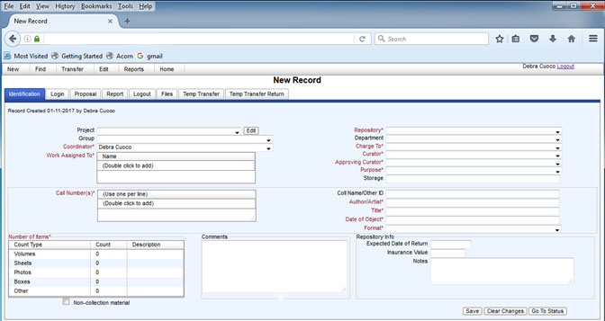

Treatment records may consist of single objects or groups of objects with similar description, condition, and treatment characteristics. If multiple objects are in one record they are required to transfer in and out at the same time.

* Enter information into all required/ relevant fields. If a required field is not filled the user will receive a warning message when saving.
* The **Coordinator** field will default to the user currently logged in. This can be changed as relevant.
* The **Comments** box should only be used for information that does not fit into one of the fields. This **Comments** box is the same on multiple pages.
* Certain fields look for duplicate entries (**Call Number**, **Title**). Upon saving the user will be prompted to review the information in these fields. ACORN will refer the user to a previous record that may contain the same object. If relevant, make note of the **Record** number, click **Override**, and **Save**.
* **Repository Info** box- these fields can be filled in by repository users at all times.
* **Clear Changes** will clear out any edits the user has made since the last Save.

# LOGIN A RECORD

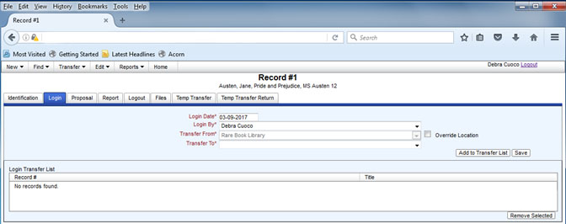

* **Login Date** and **Login By** will default to the current date and user logged in. They can be changed.
* **Transfer From** will default to the owning **Repository**. This can also be changed if the object is coming from a different location, for example, an Imaging Services department or outside institution. Choose **Override Location** and select the appropriate location.
* Choose the **Transfer To** from the drop down list.
* If click **Save**, the transfer will enter the system. If click **Add To Transfer List**, the transfer is saved and added to the **Login Transfer List** box. Once on the list, a **Transfer Form** can be created.

# TRANSFER FORM

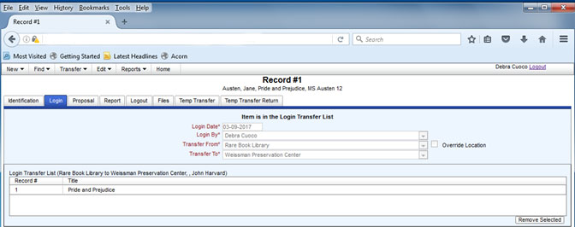

* A transfer form has one or more Records added to it. For multiple objects to be on a transfer form they must all come from the same Repository, Department, and Curator.
* In an ACORN session (period of time when a user is **Logged In** until **Logging Out**) a user may add multiple items to a transfer form. A user can add a record to the transfer list, go to a new record and add that record to the transfer list. The list will keep all added items unless the user removes the record using the **Remove Selected** button or logs out of ACORN.
* Once the transfer list is complete, click the **Reports** button on the Menu Bar. Select **Transfer Form**.

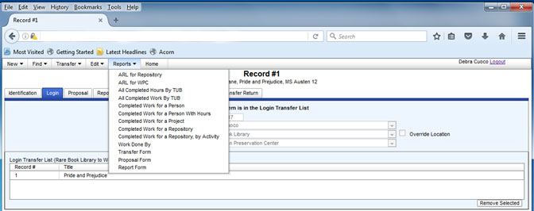

* Fill in the dialogue box and **Generate Transfer Form**.

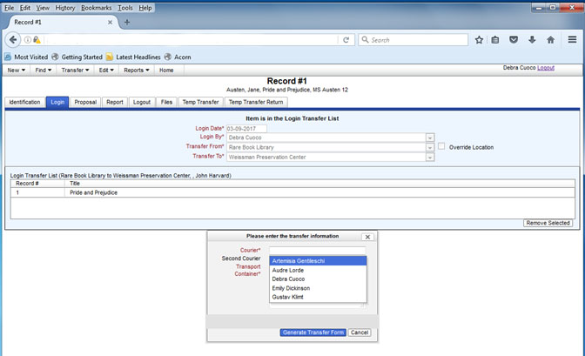

* ACORN will generate a pdf form that will open in a new window.



# CREATE/ EDIT A PROPOSAL

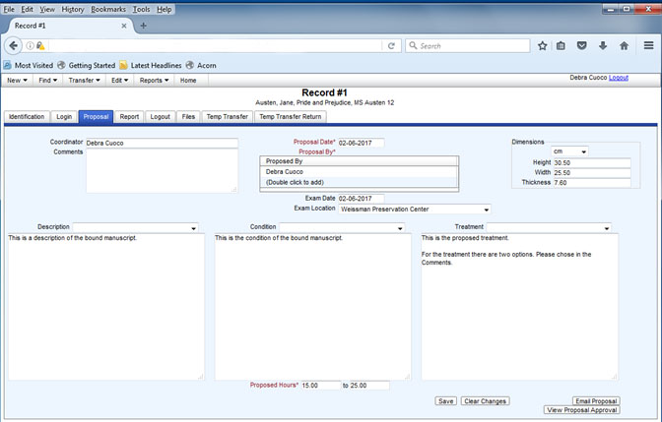

The Record Proposal describes the object(s), condition and proposed treatment.

* **Proposed By** may have multiple authors.
* The **Description**, **Condition**, and **Treatment** boxes are open text boxes. There is no capability for indenting, bold or italicizing.
* The drop down fields above the text boxes are Custom Text menus.
* Do not use < or > symbols in any text box. ACORN reads these as HTML code and any information typed to the right of < or to the left of > will delete upon saving.
* A PDF version of the proposal may be retrieved by on the upper menu, **Reports- Proposal Form**.

# EMAIL PROPOSAL

Once a proposal is written it can be directly emailed through ACORN to the Curator/ Owner for approval. Once a proposal is saved, two new buttons appear on the lower right of the Proposal page- **Email Proposal** and **View Proposal Approval**.

Clicking Email Proposal takes the user to a new page.

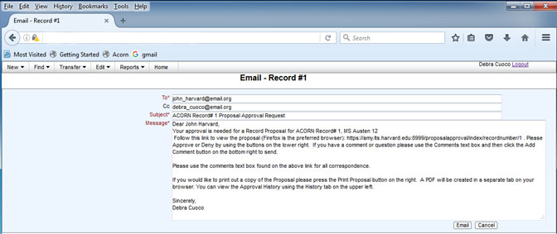

* The **To** field value will default to the Approving Curator’s email address. The Cc line will default to the user sending the email, the Coordinator, and the Proposal Author. Note these might all be the same person.
* It is important that the **To** email address is the Approving Curator and no other email address. This email address receives an email with a link to the Record that includes the ability to **Approve** or **Deny** the treatment. All other email addresses in the Cc line receive an email to view the Proposal Approval and comment, but not to **Approve** or **Deny** the treatment.
* The text in the **Subject** field and the **Message** body can be altered as appropriate. The default **Message** text can be set or altered by the IT Administrator for ACORN.

# PROPOSAL APPROVAL

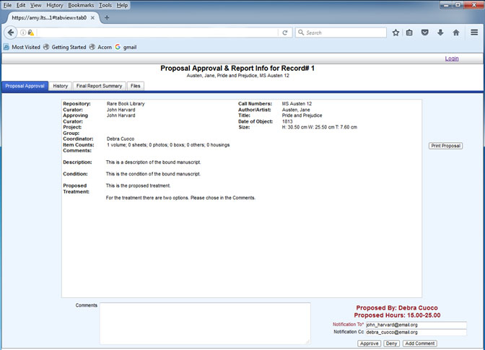

* This version is seen by the Approving Curator. All other users see this screen without the **Approve** and **Deny** buttons.
* The **Print Proposal** button opens a new tab with a formatted PDF of the proposal.
* **Comments** box- this is different than the **Comments** box seen on other pages. This box is used by Repository and Regular users to correspond directly in regards to the Proposal or Report. This eliminates the need for outside emails and saves all information related to a Record in one place.
* **Final Report Summary** shows the treatment report in the same manner as the proposal.
* **Files** allows the Curator/Owner direct access to any images or files associated with the Record.
* **History** saves all Comments directly into the history of the Record.
* Access to the Proposal Approval pages is found through the Proposal page of a Record or the hyperlink on the My Records page.

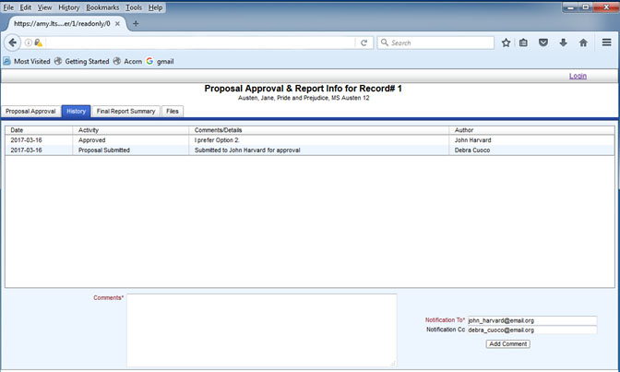

# CREATE/ EDIT A REPORT

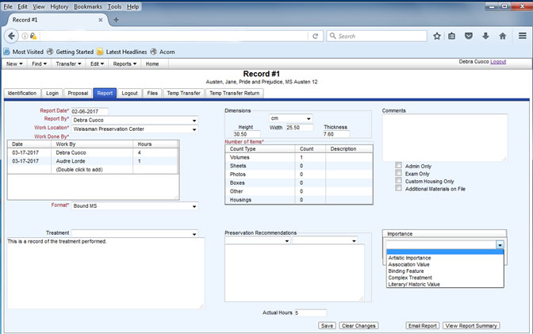

* **Report Date**, **Report By**, **Work Location** will default to current date, user logged in and previously stated **Work Location**.
* **Work Done By**- where all hours are counted. Double click to add date, user and time. User names can appear multiple times. All hours are added with the total hours in the Actual Hours field.
* **Format** and **Number of Items**- defaults to Identification page information. If the object format changes during treatment this alteration can be recorded on this page.
* **Treatment**- Open text field to record treatment. **Custom Text** may be created for this field. Additionally, there is an option present in Custom Text box for Copy Proposed Treatment. This will copy all information from the Treatment text box on the Proposal page.
* **Preservation Recommendations**- free text or custom text filed.
* **Importance**- list created through Admin functions.
* A PDF version of the report may be retrieved by on the upper menu, **Reports- Report Form**.

# FILES

Files related to a specific Record are uploaded here.

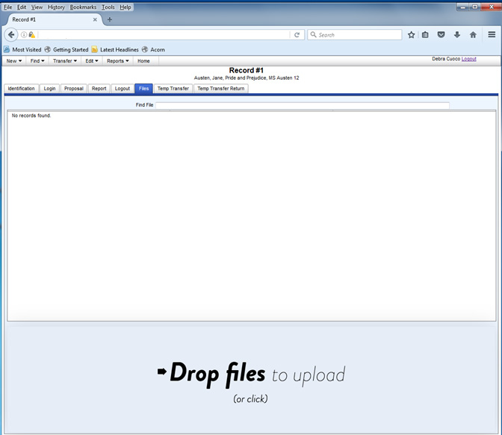

* These can be any type of file- image, document, spreadsheet, etc.
* Click **Drop files to upload**. Windows Explorer or a similar file browser will open. The user can select one or multiple files. Once selected thumbnails will appear.

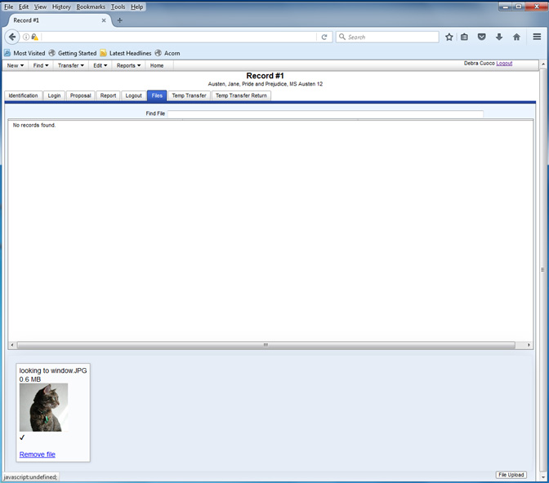

* Click **File Upload**. The files will then appear in the white box.

# LOGOUT A RECORD

Logout works exactly like Login. See directions for LOGIN A RECORD.

# TEMP TRANSFER/ TEMP TRANSFER RETURN

Temp Transfer/ Temp Transfer Return is a way to temporarily logout and login a Record that is currently in progress. This allows all the work for a specific Record to remain in one Record, with one ACORN number.

For example, an object is in treatment in the lab. Before the treatment is complete, the object needs to go to the imaging lab for a short period of time and will then return to the lab.

Temp Transfer and Temp Transfer Return function the same as Login and Logout.

# CREATE A NEW PROJECT

Records and OSW may have a Project associated with them. This assists in tracking and statistics. There are two paths to creating a Project.

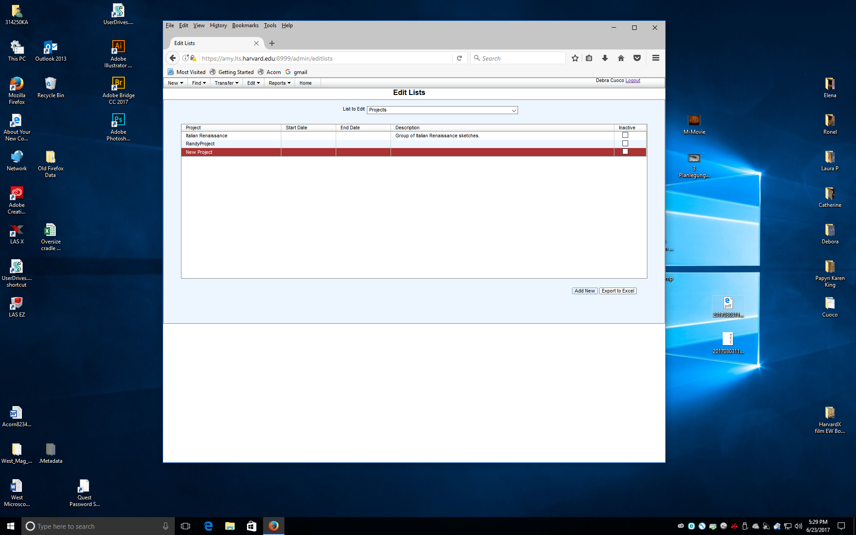

* On the Identification Page click the Edit button next to the Project field. Click Add New, scroll to bottom of the list and double click to add the Project name.
* Go to Edit- Project and repeat the above steps.

# CREATE/ EDIT CUSTOM TEXT

A user has the ability to create and save text that may be commonly repeated on certain ACORN pages. Custom Text is available for Proposals, Reports and Preservation Recommendations. Text could include citations for commonly used resources, set treatment protocols, etc.

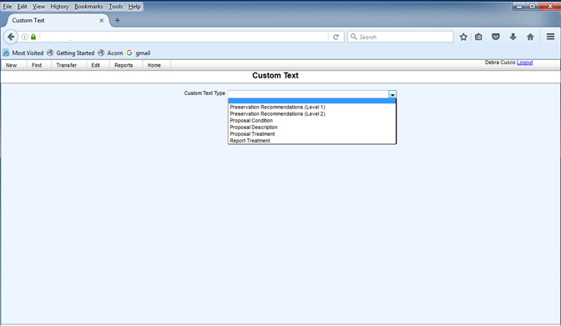

* To save specific text go to **Edit-Custom Text.**
* Choose from the drop down menus which area to save the text.
* Click **Add New**- double click to rename the Custom Text in the first box. Double click the second box to write the text to be saved.
* If the Custom Text needs to be accessible by more than one user, the Admin can make the text Global and available on all users’ drop down menus.

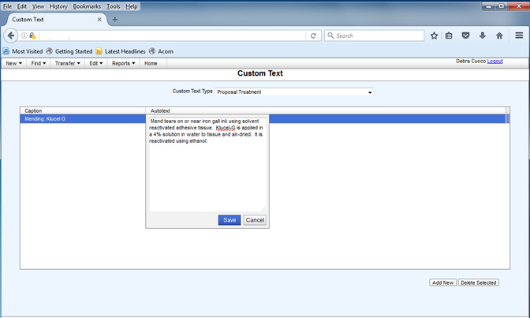

# GROUP RECORDS

Records that were created together but have separate Record numbers. This is different from a batch where multiple objects are within one record. Groups generally have similar Identification information. A group of individual Records can be created at once and partially edited all on one screen. Group functions can assist in all Record functions (Login, Proposal, Report) or all information can be written individually.

# CREATE A NEW GROUP RECORD

A group of individual Records can be created at once and partially edited all on one screen.

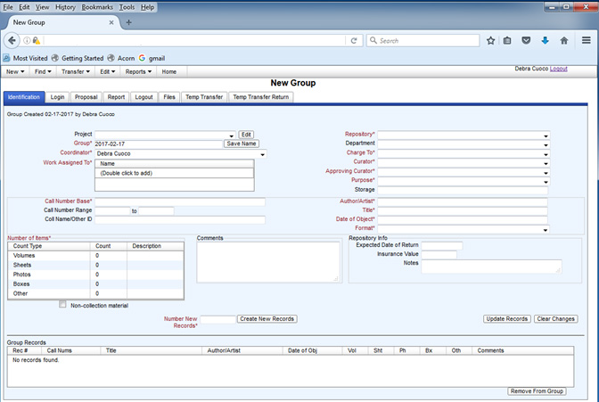

* Fill in all the fields as you would a regular Record except where noted below. Ignore the Group Records box on the bottom for the moment.
  + **Group** field name defaults to the current date. This may be changed for easier searchability when creating the Group Record. Do not edit this field once the Group is created.
  + **Call Number Base**- the call number base will be copied into each Record created. If all call numbers are different enter "~".
  + **Number of Items**- number of items in each individual Record
  + **Number New Records**- number of ACORN records to create

For example, 3 maps are being transferred for treatment. Each map needs its own Record as the treatments are very different, but they come from the same Repository and will be Logged Out at different times. "Number of items" would be 1 and "Number New Records" would be 3. (Conversely, if the 3 maps were very similar in treatment and would be transferred in and out of the lab at the same time a user could create 1 Record with 3 items.)

* Once all fields are entered, click **Create New Records**.

The new Records now show up in the Group Records box at the bottom of the page. Double-clicking any of the fields opens a text box that can be edited. Or, by clicking on the Rec# hyperlink will take you to the individual Record for editing of all fields.

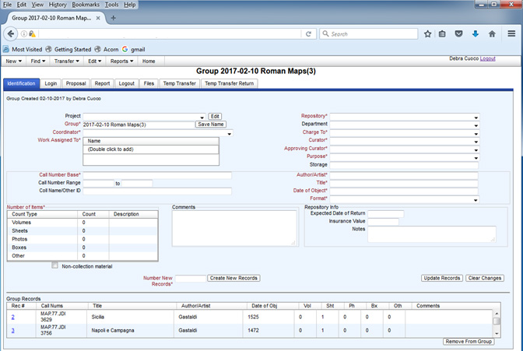

If you need to edit a field that is shared by all the Records you can do so and then click **Update Records**. The new information will write over those fields. Do not edit the **Group** name.

# GROUP- LOGIN and LOGOUT

Similar to individual Records you can Login/ Logout a Group. When a Group is Logged In or Out, all records in the Group will have the same Login information.

* Choose the **Repository for Transfer From** and the location for **Transfer To**. After selection, your Group Records should be listed in the Matching Group Records box.
* Click **Add to Transfer List** or **Save** to execute the transfer, as you would an individual Record.

# GROUP- PROPOSAL and REPORT

Functions similar to individual Records. Any information that is written in the Group Proposal or Report text boxes will be copied into each Record in the Group. You can then go into an individual Record and add/edit the information. Or, you can start the proposals/ reports directly in the individual Record.

For Treatment Reports, any time entered into a Group Report will be copied into each Report. If you enter in 1 hour into a Group Record that includes 3 individual records, you are actually adding 3 hours of time.

**NOTE**: If you have written anything in the individual Record and then go into the Group Record and edit and Save, you will lose any text that was written specifically to that Record.

# STATUS

The Status page provides a summary of a Record. The Status page may be reached in three ways;

* My Records page- hyperlink present. States the Status of the Record on this page.
* Find- Record/OSW/Status
* Identification page- From an individual record a user can toggle between the Status page and the Record-Identification page.

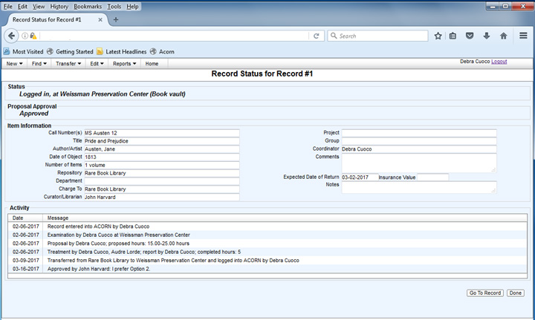

* Go To Record brings the user to the full Record.
* Done returns the user to the My Records page.

# BULK LOGIN/ BULK LOGOUT

Bulk Login/ Logout is a way to transfer multiple items at once. The requirements are the same as if the user transfer multiple items by going to each record and adding to the Transfer list.

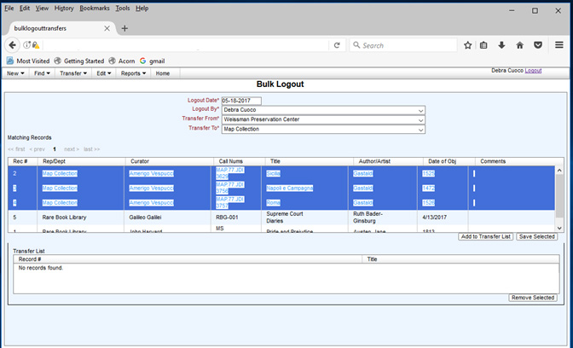

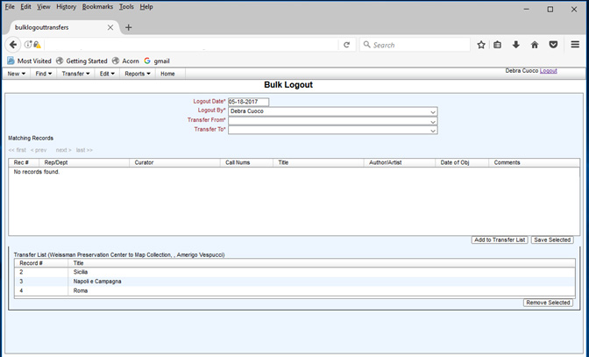

* All Records must be from the same Repository and Department (if selected).
* Go to Transfer- Bulk from the upper menu
* Choose the Transfer From and Transfer To locations.
* Select the multiple items to transfer using CTRL or SHIFT or add each separately from the list and click Add To Transfer.
* Once the first record is added to the Transfer list only the records from that Repository (and Department) will appear in the Matching Records box.
* Continue with creating the Transfer Form, if needed, as usual.

# OSW

OSW (On-Site Work) records are a way to reflect work done on-site at a repository. This can include preservation activities as well as treatment that does not require a full treatment proposal.

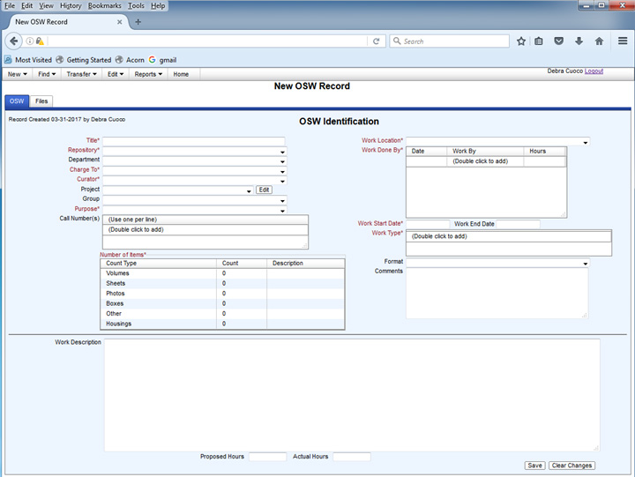

* OSW records have two pages, the Record and Files.
* Fields are filled out as other pages. Some of the required fields differ from regular records.
* Work Location reflects where the work happened.
* Work Start Date/ Work End Date- enter date when work begins. Do not put any date in Work End Date until the work is actually completed. If a date is added to Work End Date it will no longer show up on the My Records page, even if the date is in the future.
* Work Type- for regular records Work Type is Treatment. The list of work types is set by the Admin. Examples of Work Types are ;
* Emergency Prep/ Response
* Environment/ IPM
* Exhibit Prep
* Housing
* Registrarial Duties
* Research and Testing
* Survey/ Assessment
* Treatment
* Work Description- open text field
* Files tab is the same as with regular Records.

# SEARCHING AND REPORTS

# FIND A RECORD- SIMPLE

There are two ways to find a Record, OSW Record or Status. The simple way is if the Record # is known.

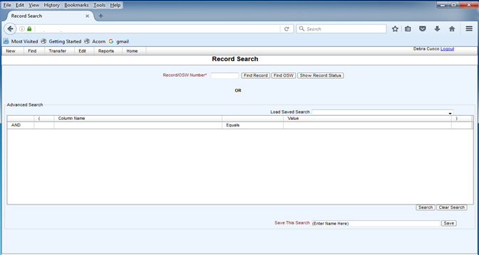

* Click Find- Record/OSW/Status
* Enter number and select type of record

# FIND A RECORD- ADVANCED

The Advanced Search is used when the ACORN # is unknown. The user can retrieve any record or groups of records in ACORN.

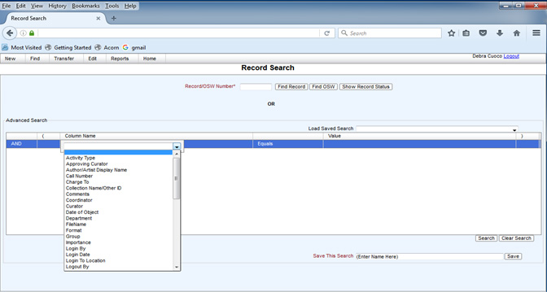

* Click Find- Record/OSW/Status
* In the Advanced Search box, the user can create simple or complex search criteria. The columns in the search are as follows;
  + First column- choices are And/ Or
  + Parentheses may be used for more complicated searches
  + Column Name includes all fields that may be present on any ACORN page
  + Depending on the Column Name the choices may be Equals/ Begins With/ Contains, <, >, etc.
  + Value is free text field or Calendar to pick specific dates
  + Once the search parameters are placed, click Search.

For example, a user wants to search for all items from the Map Collection that are Logged In. The search criteria could look like this,

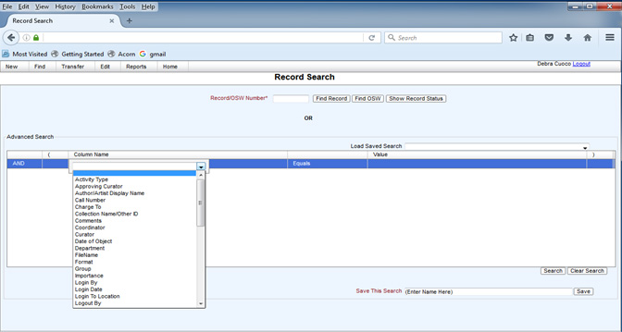

The results:

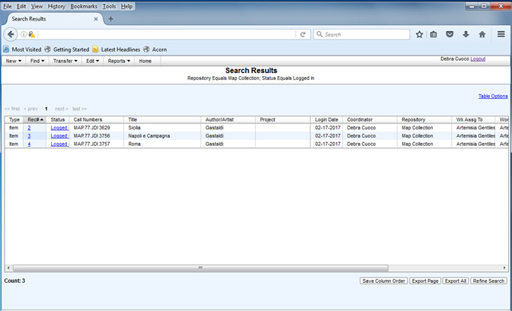

* Clicking on Table Options opens a box where the user can select which fields to display. The Column order may be changed by clicking and dragging.

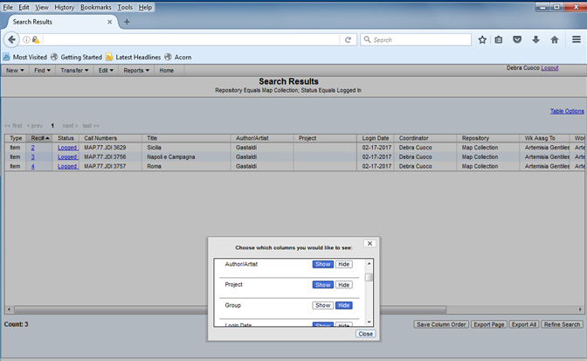

* The Rec# and Status boxes are hyperlinked and will direct to that particular Record. The data may be exported to a CSV file by clicking Export or Export All. If a search yields in multiple pages of results all results will be exported with Export All. Export does one page at a time.
* Refine Search takes the user back to the Advanced Search page.
* If the search is commonly used it can be saved by naming it in the Save this Search box on the main Search page. The saved searches are specific to each user but may be made global by an Administrator.

# REPORTS (PDFs)

Under the Reports tab are several reports with set parameters. When run with a PDF report is generated.

* These reports have set fields and display. They cannot be altered by the user. To alter or add a Report requires IT support.
* Select the desired Report and choose the parameters. A PDF is created in a second window.
* Note: The Report, Work Done By will create a CSV file that opens in Excel.

# ADMIN FUNCTIONS

# INITIAL SETUP INSTRUCTIONS

When ACORN is set up, a first user will be added as an Admin. This user will have the rights described in the Admin Functions portion of the User Manual. The Admin will first need to populate the lists used for ACORN. A few lists require population with at least one value before using ACORN. These fields are, People (at least one Regular or Admin user and one Curator), Purpose, Format and Work Types.

# EDIT- LISTS

Lists can be populated by the Admin only with the exception of Projects. To add, remove or make a list value Inactive, Go to Edit- Lists

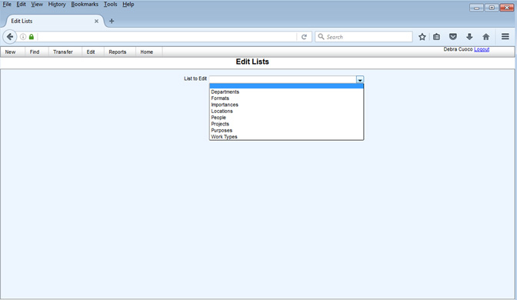

The above categories are editable. See Glossary for definitions. To add, select a List, click Add new and type in the text box.

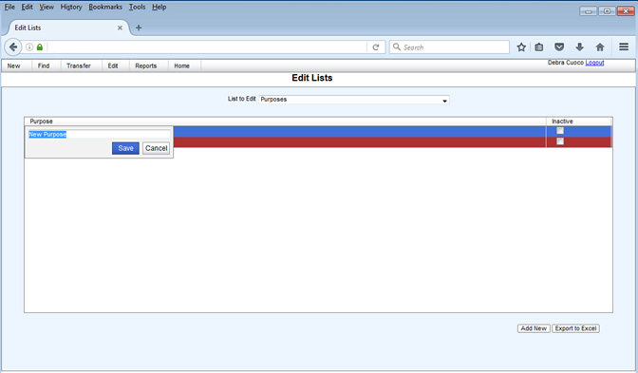

If a List value is no longer in use click Inactive. Note that if something is Inactive it can still be searched for in the search function.

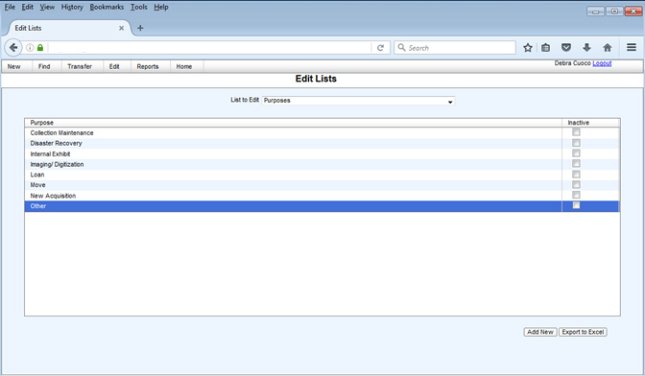

* Projects can be edited by a Regular user.
* People are best edited using Edit- Person/User rather than Edit-Lists.

# EDIT- PERSON/ USER

All user information can be found under Edit- Person/ User.

* To find a person already in the database, use the Find Person box. Autofill is activated when you start typing.
* To add New, click Add New

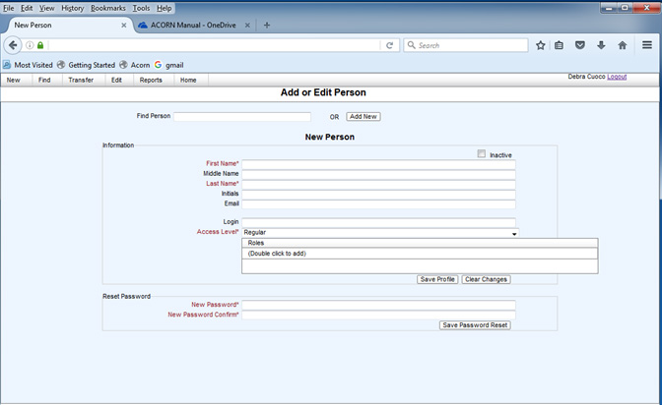

* Type in required and additional information as needed.
* Access level- the five levels of Access are as previously described.
* Roles- Contractor
  + - Curator- the person’s name will appear on the Curator list
    - Donor
    - Staff- staff should be selected for all Regular users. Staff should also be selected if your Repository user will have access to the Repository mode, and not just have access through an email link.

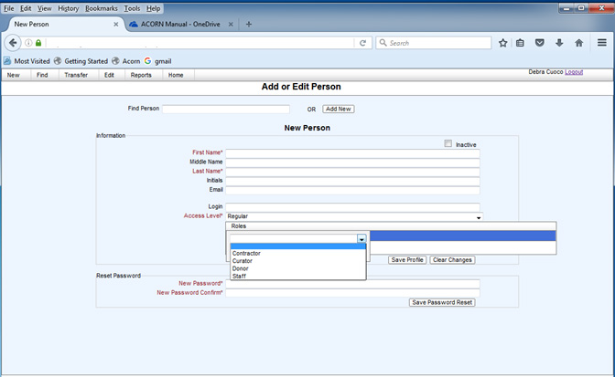

* Password- the password defaults to the login name
* Inactive removes the Person/User from drop down lists. The Person/User is still searchable in Advanced Search.

# DELETE A RECORD

If a Record needs to be deleted, often due to duplicate entry, the Admin can delete a Record. Go to the Identification page of the Record and click Delete in the bottom right. Once deleted there is no Undo.

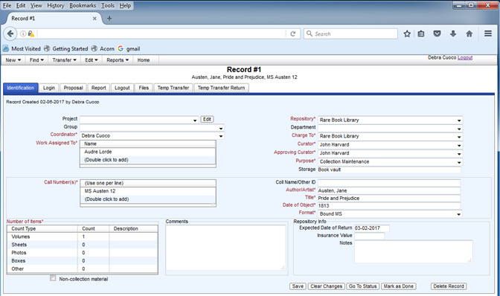

# CLOSE A RECORD/ MARK AS DONE

If a Record needs to be Closed but there is no transfer information it can be Marked As Done. For example, a Pending record is created for a Record and a Proposal has been written without the item transferring into the lab. The item is no longer coming but the user does not want to lose the information. An Administrator clicks Mark as Done. The Record no longer appears on My Records lists but is searchable.

# DELETE AND RENAME FILES

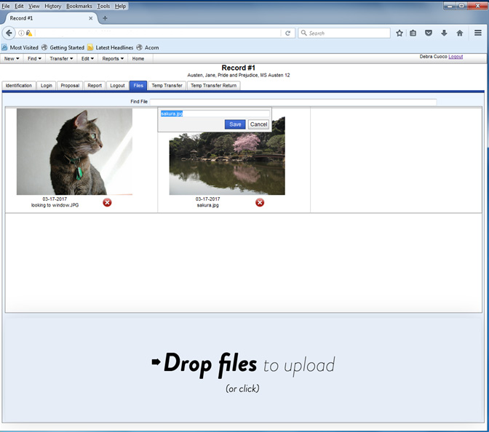

* Double clicking on a file name pops up a text box to edit the name.
* Clicking the red X will delete a file.

# UNLOCK A RECORD

Find- Record- Identification

When a Record is Logged Out, after 30 days the Record locks and becomes read-only. An Administrator can unlock a Record. On the Identification page, click Unlock Record in the bottom right. The default time is 30 days from unlocking but the Administrator can change the date as needed.

# GLOBAL OPTIONS- CUSTOM TEXT AND SAVED SEARCHES

Custom text and saved searches that need to be shared by a group of users can be made global. Global allows all Regular users to see them.

# REPOSITORY MODE

A Repository user has Read Only access to all records for their repository. A few fields have Write access.

# SIGNING IN

Same as Regular users

# MENU BARS

FIND

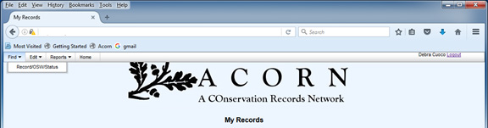

EDIT

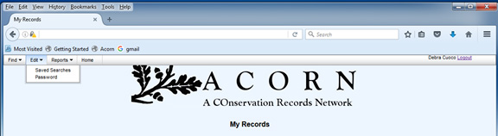

REPORTS

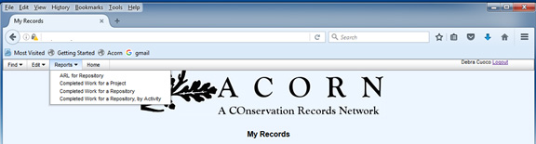

# MY RECORDS

Shows current records for the Repository associated with the Curator/ Approving Curator that is logged in.

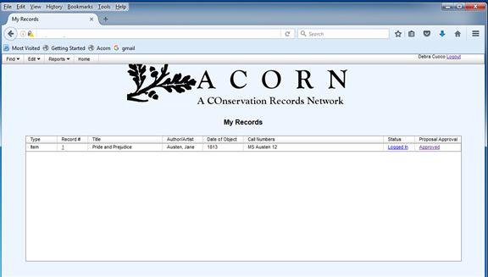

# RECORDS

# IDENTIFICATION

Repository users may edit information in a Record in one location only, the Repository Info box with the following fields,

* Expected Date of Return
* Insurance Value
* Notes- comments box for Repository staff

# PROPOSAL/ REPORT

Users can access the Proposal Approval and Report pages to Approve/ Deny and make Comments.

# FIND- RECORD

Simple and Advanced searches will only show records associated with that Repository. Results will include records associated with other Curators/ Staff from the Repository.

Searches for a user may be saved as with Regular staff users.

# EDIT

Editing is limited to Saved Searches and Password.

# REPOSITORY ADMIN

A Repository Admin has the same access as Repository with two additional functions.

* The My Records page for a Repository Admin shows all current records for a Repository, and not just the records associated with the Repository Admin’s name.
* A Repository Admin can create new Records. The Menu bar includes New- Record. The Admin can create a new Record but cannot Login a Record. Once the Record is Logged In the write access is removed.

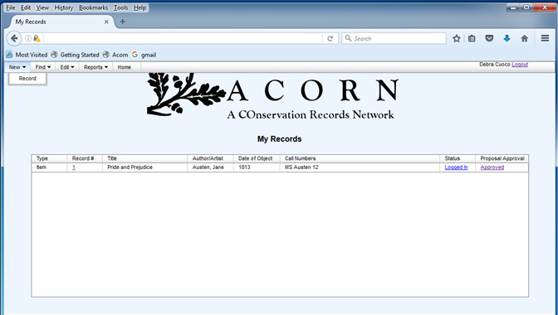

# GLOSSARY

|  |  |
| --- | --- |
| **TERM** | **DEFINITION** |
| ACORN Number | An automatically generated number created for every new Record or OSW. |
| Activity Type | Regular Records are defaulted as Treatment, OSW records as On-Site. If Records do not have Treatment they can be classified as Admin Only, Custom Housing Only, or Exam Only. |
| Approving Curator | Person responsible for approving the treatment that is not the Curator. An example is a project manager. |
| Author/ Artist | Creator of the object. |
| Batch | Multiple objects within one Record. |
| Call Number | Owner supplied unique number to identify an object. |
| Charge To | Repository or Other responsible for the billing of the work. |
| Coll Name/ Other ID | Name associated with the object that may assist in classifying and searching. |
| Comments | Information that does not fit into any other field. The Comments field repeats on multiple pages; Identification, Proposal, Report and on Transfer Forms. |
| Condition | Physical condition of an object(s) upon arrival to the lab. |
| Coordinator | Person responsible for the record. |
| Curator | Person who makes decisions regarding the stewardship of the object. |
| Date of Object | Date of creation of the object. May be a range. |
| Department | Location residing within a Repository. |
| Description | Bibliographic and visual characteristics of an object(s). |
| Expected Date of Return | Agreed upon date to return object to Repository or Owner. |
| FileName | Uploaded file names. |
| Format | Description of the physical or visual characteristics of the object. |
| Group | Records that were created together but have separate record numbers. This is different from a batch where multiple objects are within one record. Groups generally have similar Identification information. A group of individual Records can be created at once and partially edited all on one screen. Group functions can assist in all Record functions (Login, Proposal, Report) or, all information can be written individually. |
| Importance | Reason the object may have significance. For example, artistic, historic, literary, institutional, etc. |
| Insurance Value | Value supplied by Repository or Curator/Owner for the Object. |
| Login By | Person logging in object into the database. |
| Login Date | Date object is received by conservation lab. |
| Logout Date | Date object leaves the conservation lab. |
| Notes | Field for Repository or owner to make Comments. |
| Number of Items | Number of discreet items within a Record or OSW. |
| OSW | Represents any work done that cannot be documented in a Record. This may include short treatments not requiring a full proposal, assessments, emergency salvage, environmental monitoring, etc. Often represents work done “on-site” at a location outside the primary lab but not required. |
| OSW Status | Open or Closed. An OSW becomes Closed automatically after the Work End Date. |
| Project | Work that is connected by a specific project. Examples could be assessment and treatment of a collection, exhibition, loan, or environmental monitoring. The work is tagged by the project name for easier searching and analysis. |
| Purpose | Reason the treatment/ activity is being recorded. Examples include, Collection Maintenance, Disaster Recovery, Harvard Exhibit, Imaging, Loan, Move, New Acquisition. |
| Record | The primary unit for ACORN. It may represent a single item or batch of objects for treatment. Items included in a single record usually have similar characteristics and treatment protocols. If a batch, all items should ideally transfer in and out of the lab at the same time. |
| Repository | Location responsible for the object. |
| Status | Period in the timeline of an object. Also name of page with snapshot information of the object. |
| Storage | Temporary location of object, usually in a conservation lab. |
| Temp Transfer | Method to temporarily transfer and object from the lab without fully logging it out. An example would be sending an object to another location to be digitized and then returning the item to the lab for further treatment. |
| Temp Transfer Return | See Temp Transfer. |
| Title | Name of the object. |
| Transfer From | Location that the object is arriving from. Usually between the Repository and the conservation lab but may be another location, for example, an Imaging Department. |
| Transfer To | Location where the object is received. Usually between the Repository and the conservation lab but may be another location, for example, an Imaging Department. |
| Treatment | Proposed treatment steps for an object. |
| TUB | A group of Repositories under the same administration or School. |
| Work Assigned To | One or more person(s) assigned to work on the record. |
| Work Done By | One or more person(s) completing work on a record or OSW |
| Work Location | For OSW records, where the work takes place. |
| Work Start Date | Beginning date of an OSW record. |
| Work Type | Type of preservation activity. Regular Records are by default Treatment. OSW Records have choice from a drop down list populated by the Administrator and may include Emergency Prep, Assessment, Environmental Monitoring, etc. |